A Comparative Study and Performance Evaluation of Traditional Machine Learning Models vs Neural Networks for Cross-Site Scripting (XSS) Attack Detection in Web Applications

School of Computing
BCAS Kalmunai Campus

Version: 2.2


BCAS Kalmunai Campus | 392/1, Main Street,
Kalmunai | 067 222 68 77

Artificial Intelligence

Abdul Jabbar Mohamed Rusaick Mufthi
A Comparative Study and Performance Evaluation of Traditional Machine Learning Models vs Neural Networks for Cross-Site Scripting (XSS) Attack Detection in Web Applications

AJM. Rusaick Mufthi
Registration No: TJ77221
Supervisor: Mohamed Nismy

This Dissertation is submitted to the Department of Computing, School of Computing, British College of Applied Studies in partial fulfilment of the Requirement of the BTEC Higher National Diploma in Computing.

Department of Computing
School of Computing
British College of Applied Studies
2022/23
DECLARATION

I do hereby declare that this work has been originally carried out by me under the guidance of Mr. Mohamed Nismy and this work has not been submitted elsewhere for any other diploma or degree.

I certify that this dissertation does not incorporate without due acknowledgement of any material previously submitted for diploma or degree in any institution or university nor it does not contain any material previously published or unpublished by another person except where due reference is made in the text.

Signature of Candidate


CERTIFICATION

This is to certify that the dissertation titled “A Comparative Study and Performance Evaluation of Traditional Machine Learning Models vs Neural Networks for Cross-Site Scripting (XSS) Attack Detection in Web Applications” is submitted by AJM. Rusaick Mufthi having the PEARSON Registration No. TJ77221 to the Department of Computing School of Computing, British College of Applied Studies in partial fulfillment of the requirements for the award of the BTEC Higher National Diploma in Computing.

I also certify that this is his original work based on the studies carried out independently by him during the period of study under my guidance and supervision.

This is also to certify that the above dissertation has not been previously formed the basis for the award of any degree, diploma, fellowship or any other similar title.

(Signature of Supervisor)
Name: Mohamed Nismy
Position: Coordinator cum lecturer - IT
Institution: BCAS Kalmunai Campus

Date: 30/08/2025

ACKNOWLEDGEMENT

With immense gratitude and accomplishment, I write this note of acknowledgement where I must thank my module lecturer Ms. Sajeetha and my supervisor Mr. Mohamed Nismy who supported and guided me to achieve this milestone.

I also take this moment to thank my parents, family and friends who supported me in one or the other to complete my research work in a successful manner.

ABSTRACT
Web application security remains a critical challenge as attackers continuously exploit vulnerabilities to compromise user data and system integrity. Among these, Cross-Site Scripting (XSS) stands out as one of the most common and dangerous threats, enabling malicious scripts to be injected into trusted websites. Traditional rule-based and signature-based detection mechanisms often fail against obfuscated and evolving payloads, highlighting the need for more intelligent solutions.
This research presents a comparative study and performance evaluation of traditional Machine Learning (ML) models and a Neural Network (NN) approach for XSS attack detection. A preprocessed dataset of benign and malicious payloads was vectorized using character-level TF-IDF, and five algorithms were implemented: Logistic Regression, Naïve Bayes, Random Forest, XGBoost, and Multilayer Perceptron (MLP). Each model was evaluated using Accuracy, Precision, Recall, F1-score, and ROC-AUC.
The results indicate that XGBoost achieved the best overall performance (Accuracy 99.81%, F1-score 99.76%), followed closely by the MLP neural network (Accuracy 99.78%), validating the effectiveness of both boosting and deep learning approaches in XSS detection. Logistic Regression also performed surprisingly well (99.77%), showing that simpler models can remain competitive when combined with proper preprocessing. A Streamlit-based prototype system was developed to demonstrate real-time detection, bridging the gap between academic experimentation and practical application.
The study contributes to the field of AI-driven cybersecurity by offering a systematic comparison of ML and NN models for XSS detection, while also highlighting limitations such as dataset dependency and scope restriction to XSS. Future research may explore deep architectures, adversarial robustness, and multi-vulnerability detection systems to further strengthen web application security.

Keywords:
Cross-Site Scripting (XSS), Web Security, Machine Learning, Neural Networks, XGBoost, Multilayer Perceptron, TF-IDF, Cybersecurity, Streamlit, Obfuscated Payload Detection.

TABLE OF CONTENTS

1 INTRODUCTION 12
1.1 Overview 12
1.2 Background of Research 13
1.3 Problem Statement 13
1.4 Research Questions 14
1.5 Research Objectives 15
1.6 Significance of the study/Novelty 15
1.7 Scope and Limitation of the study 16
1.8 Organization of the thesis/ Structure 17
1.9 Chapter Summary 18
2 LITERATURE REVIEW 19
2.1 Overview 19
2.2 Definition of Terms 19
2.3 Theoretical Review: 21
2.4 Hypothesis: 23
2.5 Empirical Review 24
2.6 Theoretical Gaps 26
2.7 Empirical Gaps 27
2.8 Chapter Summary 28
3 RESEARCH METHODOLOGY 29
3.1 Overview 29
3.2 Theoretical Framework 29
3.3 Hypothesis 30
3.4 Operationalization 31
3.5 Conceptual Framework 32
3.6 Research Design 34
3.7 Population and Sampling - (Probability or Non-Probability) 35
3.8 Data Collection 36
3.9 Chapter Summary 37
4 DATA – ANALYSIS AND PRESENTATION 38
4.1 Overview 38
4.2 Data Analysis (Qualitative or Quantitative) 38
4.3 Descriptive Statistics Analysis/ Content Analysis (Qualitative) 39
4.4 Correlation and Regression Analysis (if needed) 41
4.5 Results of Hypothesis Testing (Regression and Comparision (t test/ Anova)) 42
4.6 Summary 44
5 FINDINGS AND CONCLUSION 46
5.1 Overview 46
5.2 Main Findings / Discussion 46
5.3 Research Contributions 49
5.4 Research Implications 51
5.5 Limitations 53
5.6 Areas for Future Research 54
5.7 Summary 56
References 58
Appendix 59

LIST OF TABLES

LIST OF FIGURES
Figure 1- Conceptual framework 35
Figure 2-Main Dataset 60
Figure 3-Preprocessed dataset 60
Figure 4-LogReg confution matrix 61
Figure 5-Naïve Bayes Confusion Matrix 62
Figure 6 - Random Forest Confusion Matrix 62
Figure 7- MLP Confusion Matrix 63
Figure 8-XGBoost Confusion Matrix 63
Figure 9- Model Performance Comparison 64
Figure 10- Model Performance Comparison (All matrix) 64
Figure 11- Traditional ML vs Neural Network 65
Figure 12- STreamlit(Running and loading all models) 65
Figure 13- Streamlit (Input Payloads) 66
Figure 14- Streamlit (Model Selection) 66
Figure 15- Code Snippets (TF-IDF Feature Extraction) 67
Figure 16- Code Snippets (Model Training (XGBoost)) 68
Figure 17- Code Snippets (Streamlit interface) 68

LIST OF ABBREVIATIONS

AP Academic Performance
BCAS British College of Applied Studies
BTEC Business and Technology Education Council
GPA Grade Point Average
TVEC Tertiary and Vocational Education Commission
UGC University Grants Commission

CHAPTERS
CHAPTER ONE

INTRODUCTION

Overview
In the modern online environment, web applications have solidified themselves as the fundamental aspects of our daily communications, commerce, education, and data sharing. While imminently useful, this equally opens these technologies to the threat of cybercrime. Of the many types of attacks targeting web applications, Cross-Site-Scripting (XSS) stands out as one of the most common and impactful client-side vulnerabilities.

XSS attacks exploit trusted sites or services by injecting malicious scripts in order to execute this code when an unsuspecting user visits the compromised site. Thereby compromising the user's account data, the attacker may perform the following actions: session hijacking, stealing credentials, impersonating the user, and manipulating user data. Despite plaintext filtering based on expected inputs, and (traditional) rule-based detection methods, XSS attack payloads are continuously evolving in order to get around security implementations.

The emergence of artificial intelligence (AI) and machine learning (ML) have provided opportunities for improving web security. Taking advantage of new ways to build models that can learn by example in order to identify unexpected behaviour within a payload on a web service is a new frontier in detection technologies. The focus of this research is the use of multiple ML models to detect XSS attacks and their implementations in a Web Application with reporting functionality that is considered the React.js framework.

This thesis will focus on the comparisons between machine learning and neural networks models in the process of detecting XSS attacks, determining which of these models are best suited to solve the problem of XSS attacks for real world. (Gupta, 2022)

Background of Research
The internet and web technologies have entirely changed how individuals and organizations operate, as web applications have become part of everything from banking and healthcare to education and e-commerce. But as digital services have grown, so has the attack surface for cybercriminals. One of the oldest and most ubiquitous threats on web applications is Cross-site Scripting or XSS.

XSS vulnerabilities can be found when an attacker is capable of injecting malicious scripts, usually JavaScript, into some content that will be executed by a user's web browser. Any malicious scripts that run in a user's browser can result in a wide variety of damaging consequences, such as cookie theft, session hijacking, defacement of websites, or redirection to malicious pages. According to the Open Web Application Security Project (OWASP), XSS has long been at or near the top of the list of security risks in the modern web world.

When it comes to preventing XSS, organizations have tools and frameworks to help with it, although it is usually a mix of input validation, content filtering, and other forms of manual rule-based systems. Although these methods are somewhat effective, attackers routinely beat them by using several encoding or character obfuscating tricks, as well as evolving their payload techniques. Because of this, many organizations have difficulties continuing to maintain effective defenses against XSS. Fortunately, recent advancements in the Artificial Intelligence (AI) and Machine Learning (ML) space have provided us new and exciting opportunities to strengthen our cybersecurity posture. (Kaur, 2023)

Problem Statement
Although an increased awareness of web application security exists, Cross-Site Scripting or XSS is still a significant threat due to its simplistic way of being executed, its multifunctionality, and its evasive nature that bypasses traditionally utilized detection methods. Several websites are still omni presently vulnerable to XSS attacks that steal data, alter information, or hijack a user session for many reasons; most notably, the site's use of dynamically typed user input.

A traditional anti-XSS method or method of reduction stains the limits of itself when it comes to complex payloads. Show-the-conventional wisdom - which is that inadequate input sanitization, lists of blacklisted patterns, or implemented content filters are all useless when hackers will exploit and utilize any form of encoding, rendering, techniques of script obfuscation, coerced browser behavior (mistakes), to insert potentially unmonitored invasive code into client-side web apps. Developers are not even able to safeguard against XSS. No offense to developers - if you build a dynamic site that accepts user input, you'll not ever have permanent prevention of an XSS if just someone literally fired away at your client-side component.

Another compelling issue is that many tools don't have a flexible implementation. A lot of tools either contain too much rigidity in their filtering architecture or were not built for a method of 'learning' from previous patterns and therefore leave themselves extremely exposed to unknown or polymorphic XSS payloads. We need intelligent, automated systems that can recognize and identify lack of input - even if the payload does not physically resemble a formatted XSS process in question! (Thajeel, 2023)

Research Questions
This research is focused on understanding how machine learning can be employed to detect Cross-Site Scripting (XSS) attacks targeting webpages. The following research questions were articulated for the study:

- What are the key characteristics of XSS vulnerabilities, and how do they impact the security of web applications?
- How do traditional machine learning models (Random Forest, XGBoost, Naive Bayes, and Logistic Regression) compare to neural network models (Multilayer Perceptron) in detecting XSS attacks?
- What is the accuracy, precision, recall, F1-score, and ROC-AUC for each of the five machine learning algorithms (Random Forest, XGBoost, Naive Bayes, Logistic Regression) and the neural network model (Multilayer Perceptron) when detecting malicious XSS payloads?
- How do traditional machine learning models perform relative to neural network models in terms of false positives, false negatives, and detection speed for real-time XSS attack detection?
- What are the most effective techniques for implementing a real-time XSS attack detection system using machine learning models, and how can the user interface be optimized for ease of use and accuracy in web applications?
- What are the challenges and limitations faced when applying machine learning models, particularly traditional vs neural network models, in detecting XSS attacks in diverse real-world web application environments?

Research Objectives
The primary aim of this research is to develop and evaluate a machine learning-based system capable of detecting Cross-Site Scripting (XSS) attacks in web inputs. To achieve this aim, the following specific objectives were established:

- To understand the nature of XSS vulnerabilities and their impact on web application security.
- To implement five selected algorithms — Random Forest, XGBoost, Multilayer Perceptron (MLP), Logistic Regression as traditional machine learning models, and neural network model as Naive Bayes — for the classification of XSS payloads.
- To evaluate each model using accuracy, precision, recall, F1-score, and ROC-AUC, and compare the performance of traditional machine learning models and neural networks in detecting malicious XSS attacks.
- To design and implement a user-friendly web-based interface for real-time XSS attack detection using trained machine learning models.

These objectives guided the research process from problem identification through to practical system development and evaluation.

Significance of the study/Novelty
This study is important because it explores one of the most prevalent and dangerous weaknesses in web security, Cross-Site Scripting (XSS), using an AI Driven methodology. Where others rely on a pre-defined set of static detection options, rules, or blacklists, this research examined the variability and adaptability of machine learning algorithms to classify and isolate malicious web payloads more accurately.

The innovative aspect of the study comes from the fact that we developed a comparative implementation driven approach. Five machine learning models were trained and evaluated, based on a structured dataset of XSS payloads: Logistic Regression; Naive Bayes; Random Forest; Multilayer Perception (MLP), and XGBoost, and their outcomes and performance were compared using standard evaluation metrics, as well as real-world usability, adaptability, and resource efficiency.

To take the research a step further than most by providing direct system interaction, we presented a practical solution: a user friendly, live XSS detection interface with Streamlit. Users will be able to enter a payload, select a model, and instantly view feedback from their selected model. This also demonstrated how AI can be effectively applied in live environments to improve security, every day.

This study has value and represents a thorough contribution to AI Driven cyber security as it includes experimentation with each model, performance benchmarking, and it provides a real-time utility. The study offers both proof of concept and application foundation. (Alsmadi, 2020)

Scope and Limitation of the study
- Study Scope: This study focuses on the application of machine learning (ML) and neural networks (NN) for detecting Cross-Site Scripting (XSS) attacks in web applications. The key areas covered in this research are:
- Detection Mechanisms: The study explores how ML models, such as Random Forest, XGBoost, Naive Bayes, Logistic Regression, and Multilayer Perceptron (MLP) neural networks can be employed to detect XSS vulnerabilities in web applications.
- Data Analysis: The research involves the use of XSS payload datasets to train, evaluate, and compare the performance of the models.
- Performance Evaluation: The study evaluates these models using performance metrics such as accuracy, precision, recall, F1-score, and ROC-AUC.
- XSS attack Detection: The study will also cover the design and implementation of a web-based interface for real-time XSS attack detection using the trained models, utilizing tools like Streamlit for interactive visualization.

- Study Limitations: While the study aims to provide a comprehensive analysis of XSS detection using ML and NN models, the following limitations must be acknowledged:
- The models were trained and evaluated on a specific dataset and may not accurately generalize to all types of real-world XSS variants, including zero-day or heavily obfuscated payloads that were absent from the training dataset.
- The Streamlit-based detection system was intended for demonstration purposes and local evaluation and was not integrated with live production web environments (including firewalls or content filters).
- This study only focused on XSS attacks and did not have any other web vulnerabilities, including SQL injection, cross-site request forgery (CSRF), or remote code execution attacks.

Despite these limitations, the study lays a strong foundation for future development of AI-based web security tools and highlights the potential of machine learning in threat detection. (Bishop, 2018)

Organization of the thesis/ Structure
This thesis is organized into seven chapters, each contributing to the overall research on detecting Cross-Site Scripting (XSS) attacks using machine learning techniques. The structure of the thesis is as follows:

- Chapter 1 – Introduction:
This chapter provides an overview of the research, background of the study, problem statement, research questions, objectives, scope, and significance. It sets the foundation for understanding the need for intelligent XSS detection mechanisms.
- Chapter 2 – Literature Review:
This chapter presents a review of related studies and existing work on XSS vulnerabilities, traditional detection methods, and the application of machine learning in web security. It also identifies research gaps and justifies the approach taken in this study.

- Chapter 3 – Research Methodology:
This chapter outlines the methods used to collect and preprocess the dataset, the machine learning models implemented, the tools and technologies used, and the evaluation metrics employed. It also includes a description of the Streamlit system implementation.
- Chapter 4 – Data Analysis and Presentation:
This chapter presents the results of model training and evaluation. Performance metrics such as accuracy, precision, recall, F1-score, and ROC-AUC are compared across all models. Visualizations such as ROC curves and confusion matrices are included for clarity.
- Chapter 5 – Findings and Conclusion:
This chapter discusses the key findings based on the experimental results. It compares traditional and neural approaches, identifies strengths and limitations of each model, and concludes with insights on real-world applicability and suggestions for future work.
- Chapter 6 – References:
This section lists all academic papers, articles, tools, and frameworks that were cited and used throughout the research.
- Chapter 7 – Appendix:
The appendix contains supporting materials such as raw result tables, screenshots of the Streamlit application, code snippets, and example XSS payloads used for testing. (Goodfellow, 2016)

Chapter Summary
In this chapter, the research topic was framed by discussing the importance of Cross-Site Scripting, (XSS) vulnerabilities in the context of modern web application security. This chapter outlined how existing detection techniques for XSS vulnerabilities are limited, so a machine learning approach may provide automation and randomized intelligent threat detection.

CHAPTER TWO

LITERATURE REVIEW

Overview
This chapter includes a thorough assessment of the literature related to detection of Cross-Site Scripting (XSS) attack using artificial intelligence (AI) or machine learning (ML) / deep learning (DL) techniques. With the sophistication and number of cyber-attacks growing, particularly increasing sophistication and frequency of XSS attacks, traditional detection methods will not work when adapting to new attack patterns. Thereby, researchers have started to focus on improving the security of web applications through utilizing AI-based models.

The review establishes various methods that have been used in the detection of XSS vulnerabilities while focusing within ML/DL models and algorithms i.e., decision trees, support vector machines, neural networks, LSTM and CNN. Additionally, the literature review cites for example key studies including GeneMiner, as well as systematic literature reviews by Isam Kareem Thajeel et al., which identifies various approaches with redesigning features, approaches in data pre-processing, and evaluations metrics to improve model performance. Moreover, the literature identifies a movement towards adversarial samples instead of detection of the 'direct detecting ability of an attacker or XSS attacks, and finally using genetic algorithms in response to the changes in payload structure.

This chapter is structured to discuss the prior and current methods; to commence to establish some of the gaps; and may assist identifying some relevance and novelty in what is being presented in this study to provide a sound AI-based XSS detection system. (Gupta, 2022)

Definition of Terms
Below are definitions of key terms and abbreviations used throughout this study:

- XSS (Cross-Site Scripting): A type of security vulnerability that allows attackers to inject malicious scripts into web pages viewed by other users.
- Payload: In cybersecurity, a payload refers to the part of transmitted data that performs a malicious action, such as a script in an XSS attack.
- Benign Input: A normal or safe user input that does not contain malicious code.
- AI (Artificial Intelligence): The simulation of human intelligence processes by machines, particularly computer systems.
- ML (Machine Learning): A subset of AI that allows computers to learn from data and make predictions or decisions without being explicitly programmed.
- DL (Deep Learning): A more complex subset of machine learning that uses neural networks with multiple layers to model high-level abstractions in data.
- TF-IDF (Term Frequency–Inverse Document Frequency): A statistical technique used to evaluate how important a word or character pattern is to a document in a collection, commonly used in text classification.
- SVM (Support Vector Machine): A supervised learning algorithm used for classification and regression tasks by finding the optimal hyperplane that separates data points.
- MLP (Multilayer Perceptron): A type of neural network composed of multiple layers of neurons, used in deep learning for classification problems.
- CNN (Convolutional Neural Network): A deep learning architecture commonly used for image data, but sometimes adapted for sequence data in security contexts.
- ROC-AUC (Receiver Operating Characteristic – Area Under the Curve): A performance measurement metric used to evaluate the accuracy of classification models.
- Precision: The proportion of true positive results among all predicted positives.
- Recall (Sensitivity): The proportion of true positive results among all actual positives.
- F1 Score: The harmonic means of precision and recall, used as a balanced measure of accuracy.
- Streamlit: An open-source Python framework used to create interactive web applications for data science and machine learning projects.
- Obfuscation: A method used by attackers to make code or data difficult to detect by hiding or altering its true intent.
- Zero-day Attack: An attack that exploits a previously unknown vulnerability for which no patch or fix is available at the time of the exploit.

Theoretical Review:
This section provides the theoretical basis for developing an AI driven XSS detection evaluative by addressing key concepts centered on cybersecurity risks, supervised machine learning and the algorithms commonly used in this study.
1. Cross-Site Scripting (XSS) Attacks:
XSS is a common vulnerability of web applications where a malicious actor injects a harmful script into content provided by a trusted source. The three main types of XSS attacks are;
- Stored XSS: A legit web app allows information that persists on the server i.e., that is not ephemeral (e.g., database or forum post).
- Reflected XSS: The web server reflects the malicious payload back to the user. Typically, a URL or via some type of user input (e.g., script).
- DOM-based XSS: The attack executes only in the browser using the Document Object Model.
- Knowing how those attacks are organized matters so machine learning features can identify the attacks appropriately.

2. Supervised Machine Learning Theory:
Supervised learning is one of the categories of machine learning when the learning algorithm learns from labeled data; in this example, input that has been labeled benign or malicious. The learning algorithm learns to recognize patterns based upon the features of the input data that are predictive of their class.

The process includes:
- Feature extraction (e.g., TF-IDF of character n-grams)
- Model training (e.g., Random Forest, Logistic Regression)
- Prediction and evaluation on unseen data

This theory allows systems to adapt to new payload structures and detect even novel attack patterns.
3. Text Feature Engineering for Security:
In terms of XSS detection, user input is seen as unstructured text. The key challenge is how to change this input, which is unstructured, into a set of numerical features suitable for a machine learning model. A popular approach is to calculate:
- TF-IDF (Term Frequency-Inverse Document Frequency): A statistical and linguistic method to find out which sequence of characters are the most valuable in differentiating benign from malicious inputs.
Additionally, approaches like Truncated Singular Value Decomposition (SVD) for dimensionality reduction could be applied to lessen the problems of high-dimensional feature spaces.
4. Classification Algorithms:
This study refers to a selection of ML classifiers, each originated from different considerations:
- Logistic Regression: A linear model for binary classification methods, which is used to calculate the probability that an input belongs to a certain class.
- Naive Bayes: A statistical classifier based on Bayes’ Theorem, that posits independence between features. Naive Bayes is comparatively faster and reliable for text classifications.
- Random Forest: An ensemble method, that generates many decision trees and combines them in order to maximize the accuracy of prediction.
- XGBoost (Extreme Gradient Boosting): An advanced boosting technique that focuses on training trees to correct the errors made by previous trees.
- Multilayer Percepton (MLP): A deep neural network which can model non-linear relationships.
Each of these models operates under different assumptions and mathematical foundations, providing diversity in detection capabilities.
5. Evaluation Theory:
Classification models need an evaluation metric that balances correctness and completeness. The metrics utilized in this study include:
- Accuracy: The overall correctness.
- Precision: The number of correct positive predictions divided by the number of positive predictions.
- Recall: The number of correct positive predictions divided by the actual number of positives.
- F1-Score: The harmonic means of precision and recall.
- ROC-AUC: The model's ability to tell two different classes apart based off a near-continuous probability at various thresholds.
These theories are foundational in guiding the structure, implementation, and evaluation of the AI models used in this project.

Hypothesis:
In the context of this study, the hypothesis is formulated to compare the performance of traditional machine learning models and neural network models in detecting Cross-Site Scripting (XSS) attacks in web applications. The hypothesis is central to determining whether neural network-based models outperform traditional machine learning models in terms of detection accuracy and efficiency.
- Null Hypothesis (H₀):
There is no significant difference in the performance of traditional machine learning models (such as Random Forest, XGBoost, Logistic Regression, and Naive Bayes) and neural network models (such as Multilayer Perceptron (MLP)) in detecting Cross-Site Scripting (XSS) attacks in web applications.

- Alternative Hypothesis (H₁):
Neural network models (such as Multilayer Perceptron) will significantly outperform traditional machine learning models (such as Random Forest, XGBoost, Logistic Regression, and Naive Bayes) in detecting Cross-Site Scripting (XSS) attacks in web applications.
Rationale:
- Traditional ML Models: These models have been used widely for many years and have established effectiveness in classification tasks, including detecting known attack patterns. However, they are often limited by feature extraction complexity and their ability to generalize well for new, unseen attack patterns.
- Neural Network Models: Neural networks, particularly deep learning models like MLP, have shown promise in handling more complex data representations, such as high-dimensional features. They can potentially learn deeper patterns in XSS payloads and adapt better to evolving attack vectors.
The goal of this hypothesis is to test the performance of both approaches and to determine if the flexibility and advanced learning capabilities of neural networks justify their use over more traditional machine learning methods for XSS detection in web applications.

Empirical Review
A number of recent studies have investigated the use of machine learning techniques in detecting Cross-Site Scripting (XSS) attacks. These studies provide a basis for understanding existing approaches, their strengths and weaknesses, and suggest where research may be lacking. Presented here is a selection of important findings taken from relevant empirical studies.
1. Detection of Cross-Site Scripting (XSS) Attacks Using Machine Learning Techniques – A Review (Kaur, 2023)
This study provides a comprehensive review of machine learning techniques used in XSS attack detection. The algorithms are categorized into traditional algorithms (i.e., Naive Bayes, SVM, Decision Trees) and deep learning models (i.e., CNNs, RNNs) and then scored for accuracy and feature extraction techniques. The review showed that datasets must be well pre-processed. The review also concluded that n-gram–based TF-IDF can be more beneficial for text-based payloads. The review concluded that a hybrid model that draws from both traditional models but also utilizes deep learning may lead to the best performance.
Relevance: This review provided strong support for each of the ML models used in this study, specifically both traditional models, and neural networks for use in XSS detection approaches, aligning directly to the aims of comparing XSS detection capability.

2. GeneMiner: A Classification-Based Approach to Detect XSS (Gupta, 2022)
This paper presents a new classification-based system named GeneMiner, which detects XSS payloads using genetic algorithms to select features and a Naive Bayes model for classifying payloads. The model was trained on both expert-designed and encoding-based payloads that simulated a real-world attack environment. GeneMiner achieved reasonable classification accuracy which suggests no matter how basic the model, if we select features effectively, accurate classifications are achievable.
Relevance: The GeneMiner study shows that even basic models, such as Naive Bayes, can provide reasonable accuracy when combined with feature engineering. This adds some support for including Naive Bayes in the model comparatives of this research.

3. Machine and Deep Learning-Based XSS Detections Methods: A Systematic Literature Review (Thajeel, 2023)
This paper offered a systematic review of the use of machine learning and deep learning models to detect XSS. The authors show that simple classifiers may perform worse than models using LSTM, CNN, and hybrid architectures especially if there are advantages to enough training rows of data. The authors discuss the challenges of data imbalance and high dimensions of feature space, and adversarial obfuscation.
Relevance: This paper also supports the introduction of a deep learning model (in this study an MLP) along with the significance of preprocessing and model evaluation - which this study has both considered.
Summary of Findings:
Based on the provided articles, the following direct findings were made:
- Conventional models of machine learning are still useful and computationally inexpensive.
- Models using neural networks generally have better predictive performance when more and better data is available.
- Simpler feature extractors, such as TF-IDF n-grams, have been used and accepted in the scientific community.
- Preprocessing, quality of dataset, and adversarial robustness are crucial factors for the performance of a model.
The information above further validates the approach related to the study which incorporates multiple supervised models, TF-IDF vectorization, balanced evaluation, and a pipeline that will allow for immediate application.

Theoretical Gaps
Although several studies have explored the use of machine learning and deep learning models in detecting Cross-Site Scripting (XSS) attacks, certain theoretical gaps still exist in the current body of research:
1. Lack of Real-Time Implementation:
Most reviewed studies focus primarily on algorithm performance in isolation, without integrating these models into a usable, real-time detection system. This gap limits the practical application of otherwise accurate models.
2. Limited Comparative Analysis Across Model Types:
While many works implement either traditional machine learning or deep learning, few perform a direct, structured comparison between the two within the same experimental setup. This hinders a clear understanding of when one type outperforms the other.
3. Underutilization of Lightweight Neural Networks:
Deep learning models like LSTM and CNN are frequently emphasized in literature, but less attention is given to simpler feedforward models like the Multilayer Perceptron (MLP), which can offer excellent performance with lower resource consumption.
4. Insufficient Emphasis on Feature Engineering for Payloads:
Many existing approaches overlook the strength of character-level analysis using TF-IDF n-grams — a feature extraction technique well-suited for identifying obfuscated or encoded payload patterns typical in XSS attacks.
5. Model Deployment and Usability Challenges:
Very few academic works translate their research into interactive, user-facing applications that allow security analysts or developers to test inputs on-the-fly. This weakens the bridge between theory and real-world utility.
This research aims to fill these gaps by:
- Comparing five ML models (both traditional and neural network-based)
- Using consistent preprocessing and evaluation criteria
- Employing character-level TF-IDF features,
- And building a deployable XSS detection system using Streamlit for local testing and demonstration.

Empirical Gaps
Despite the growing body of research on using machine learning for Cross-Site Scripting (XSS) detection, several empirical gaps still remain in current studies:
1. Limited Dataset Diversity and Availability:
Many prior studies rely on closed or outdated datasets, making it difficult to reproduce results or test model robustness. Publicly available datasets are often small or lack proper labeling and preprocessing.
2. Inconsistent Evaluation Metrics:
Some works report only accuracy, ignoring other important metrics such as precision, recall, F1-score, and ROC-AUC. This limits the ability to compare models fairly, especially in imbalanced datasets like XSS payload detection.
3. Minimal Focus on Lightweight Implementation:
Although high-performing models like deep neural networks are popular, few studies explore lightweight models that offer similar results with less computation critical for real-time applications.
4. Scarce Integration into Usable Tools:
Most academic efforts stop at model training, with little emphasis on turning the trained model into a usable tool for security professionals or developers. The lack of interfaces or APIs weakens the real-world impact.
5. Neglect of False Positive Analysis:
Few studies investigate how well models avoid flagging benign input as malicious a crucial issue in usability, especially in production systems where false positives can disrupt legitimate user activity.
This study addresses these empirical gaps by:
- Using a cleaned dataset
- Evaluating models with five robust metrics (Accuracy, Precision, Recall, F1, ROC-AUC)
- Implementing both traditional and neural models for practical comparison,
- Deploying the system with a user interface via Streamlit, and
- Ensuring reproducibility and clarity for future research extensions.

Chapter Summary
In this chapter the available literature surrounding Cross-Site Scripting (XSS) vulnerability and how machine learning methods can help in web security has been discussed. Some key definitions and theories, including supervised learning, TF-IDF vectorization, and classification algorithms, were identified and discussed to help establish a starting point for the research process.
There was an analysis of empirical studies that are useful in demonstrating the varying methods, algorithms, datasets and feature extraction methodologies for XSS attack detection. The literature review found, both gaps in the theoretical literature and analysis on the empirical literature, especially with the implementation of XSS detection in real-time, comparative analyses of methods that saw the formulation of the different approaches, and the implementation of a model in practical scenarios.
The research will attempt to fill these gaps in order to advance the field by creating and assessing a range of machine learning models and developing and exposing a usable system for detecting XSS vulnerabilities. In the following chapter the research design will be briefly described, followed by the dataset, then model implementation, and lastly the evaluation process to achieve the stated objectives.

CHAPTER THREE

RESEARCH METHODOLOGY

Overview
This chapter outlines the approach used to meet the research objectives set out above This was a controlled experimental study with a quantitative approach. It uses the machine learning techniques to detect Cross-site Scripting (XSS) attacks in web input data.
We First Start Our Research on Structured XSS dataset Extraction and Pre-processing. After that, it does feature extraction by char level TF-IDF Vectorizer. The dataset is used to implement and train a number of supervised learning algorithms which includes: Logistic Regression, Naive Bayes, Multilayer Perceptron (MLP), Random Forest, XGBoost.
Post-training, the models are rated using standard performance metrics like accuracy, precision, recall F1 score and ROC-AUC. Finally, the models embedded in a streamlit app to describe its real time accessibility which is user-friendly detection system.
The methodology ensures a practical, reproducible, and performance-focused approach to comparing traditional and neural network models in the context of AI-based web security. (Gupta, 2022)

Theoretical Framework
This approach was based on the classical theory of supervised machine learning problem type in which a model has to learn from labeled data and then able to predict new inputs. For instance, in a cybersecurity scenario were finding Cross-Site Scripting (XSS) attacks are at play, sometimes the machine learning model can be employed to establish malicious payloads through naked patterns hidden within input data.
The theoretical foundation of this study is based on the essential constituents:
- Supervised Learning Theory:
This corresponds to prior work in supervised learning, which is what we are doing: training models on a dataset with known inputs and outputs in this case, web payloads that have been labeled by domain experts as either malicious (XSS) or benign. This model learns map between the input features and target labels that help it in detecting unseen attacks.
- Feature Engineering using TF-IDF:
The Term Frequency–Inverse Document Frequency (TF-IDF) method is generally applied to translate unstructured text data into numerical features. Character-level n-gram vectorization is able to capture patterns, obfuscations and signature characteristics often present in malicious scripts and hence suitable for XSS payload detection.

- Classification Algorithms:
Five classification models are used in this study, each based on different theoretical principles:
- Logistic Regression: Linear classification based on probability estimates.
- Naive Bayes: Probabilistic classification assuming feature independence.
- Multilayer Perceptron (MLP): A simple neural network that models complex relationships.
- Random Forest: Ensemble learning using multiple decision trees.
- XGBoost: Gradient boosting that optimizes performance through iterative corrections.
These models are evaluated based on their ability to generalize from training data and correctly classify real-world inputs.
- Evaluation Metrics:
To determine model effectiveness, standard metrics from information retrieval and classification theory are used: Accuracy, Precision, Recall, F1-score, and
ROC-AUC. These metrics help balance detection capability with false positive control.
This system involves how established paradigms from machine learning, natural language processing, and web security could be brought together now to formulate a robust operational framework for XSS attack detection. It can also enable the comparative analysis that can be made between the traditional algorithms and neural networks while addressing the core research question regarding which performs better in this context. (Thajeel, 2023)

Hypothesis
The hypothesis for this research is centered around the performance comparison of traditional machine learning models and neural network-based models in detecting Cross-Site Scripting (XSS) attacks. These hypotheses guide the experimentation and evaluation phase of the study.
- Null Hypothesis (H₀):
There is no significant difference in the detection performance between traditional machine learning models (e.g., Logistic Regression, Naive Bayes, Random Forest, XGBoost) and the neural network-based model (MLP) in identifying XSS attacks.

- Alternative Hypothesis (H₁):
There is a significant difference in the detection performance between traditional machine learning models and the neural network-based model in identifying XSS attacks.
These hypotheses are tested by implementing and evaluating five selected classification models using a structured and preprocessed XSS dataset. The evaluation metrics used to test the hypotheses include Accuracy, Precision, Recall, F1-score, and ROC-AUC.
The model performances are compared, and the results are analyzed to determine if the neural network model offers a statistically significant advantage over traditional approaches in the context of AI-driven web security.

Operationalization
This project links theory to practice by operationalizing key variables and concepts through a set of defined steps and measurable indicators. Effectively turning the idea of "effective XSS detection" into a repeatable machine learning-oriented pipeline and evaluation framework.
1. XSS Detection as a Classification Problem:
The primary concept detecting malicious XSS payloads is operationalized as a binary classification problem, where:
- Label 1 represents a malicious (XSS) payload.
- Label 0 represents a benign payload.
2. Input Features:
The raw input text (payloads) is converted into numerical form using:
- TF-IDF Vectorization at the character level (2- to 4-gram range).
This technique enables the models to recognize patterns, obfuscation, and embedded scripts common in malicious input.
3. Model Training:
Five machine learning models are trained using a supervised learning approach:
- Logistic Regression
- Naive Bayes
- Multilayer Perceptron (MLP)
- Random Forest
- XGBoost
Each model is implemented using Python and scikit-learn (and XGBoost library) and trained on the same preprocessed dataset split into training (80%) and testing (20%).
4. Performance Measurement:
Model effectiveness is evaluated using five key metrics:
- Accuracy: Overall correctness of predictions.
- Precision: How many predicted malicious inputs were truly malicious.
- Recall: How many actual malicious inputs were successfully detected.
- F1 Score: The harmonic means of precision and recall.
- ROC-AUC: The model’s ability to distinguish between the two classes across all thresholds.
These metrics are computed using the test set and are used to compare traditional models with the neural network-based approach.
5. System Implementation in Streamlit:
The final part of the research involves deploying the trained models using a Streamlit-based user interface, enabling real-time testing of payloads and demonstrating how the models can function in a real-world web security environment.
This structured operationalization ensures that each abstract component of the research is made concrete and measurable, supporting both reproducibility and meaningful comparison.

Conceptual Framework
The research conceptual framework is the structure of logic and flow, beginning with the identification of a problem and culminating in the development and deployment of a machine learning–based XSS detection system. Its apparent relationship indicates the flow of the input data through the ML models to evaluation in the real-time detection interface output.
This framework is designed to align with the research objectives and demonstrates how each phase of the methodology contributes to addressing the research questions.
Key Components:
- Input Layer:
- XSS Payload Dataset (Labeled)
- Preprocessing
- Feature Extraction using Character-level TF-IDF

- Processing Layer (Model Training):
- Model 1: Logistic Regression
- Model 2: Naive Bayes
- Model 3: Multilayer Perceptron (Neural Network)
- Model 4: Random Forest
- Model 5: XGBoost
- Dimensionality reduction & scaling

- Evaluation Layer:
- Performance Metrics: Accuracy, Precision, Recall, F1 Score, ROC-AUC
- Comparative Analysis of ML vs Neural Network Models

- Output Layer:
- Best-performing model identified
- Real-time system deployment using Streamlit interface
- Usability testing with known benign and malicious inputs
Conceptual Framework Diagram:

Figure 1- Conceptual framework

Research Design
The research employs an explanatory research design within a quantitative paradigm. The objective of this study is to examine the correlation between the several machine learning algorithms and their effective use in the detection of Cross-Site Scripting (XSS) attacks.
With explanatory research design:
The study explains "why" and "how" certain machine learning models are better than others in classifying malicious and benign web payloads. With comparative experimentation, the research buttresses its way of explaining the differences by bringing in empirical evidence in respect of the models' performance and thus adds to the understanding of AI-based web security systems in general.
Quantitative Research Approach:
A quantitative approach is adopted to:
- Collect and preprocess numerical and categorical data (from labeled XSS datasets),
- Train classification models using measurable input-output pairs,
- Evaluate model performance using statistical metrics such as Accuracy, Precision, Recall, F1-Score, and ROC-AUC.
All stages of the research, from gathering data to final model earnings appraisal and getting it up and running, revel in the calm reassurance of numerical evidence and statistical significance with perfectly good objectivism and reproducibility.
This algorithm exploration is designed to find the most efficient and precise algorithm for the detection of XSS payloads in close acquittance with the primary research objectives and hypotheses.

Population and Sampling - (Probability or Non-Probability)
The dataset includes all web application inputs bearing damage or healthy scripts and, particularly payloads that could be identified as "possible Cross-Site Scripting (XSS) attacks" or clean from real-world or artificially simulated sources.
This research sample consists of a well-structured and labeled dataset of XSS payloads, including "malicious (positive)" and "benign (negative)". This dataset was collected from open-source repositories, from academic datasets known for the known examples of XSS attacks, then cleaned, filtered, and pre-processed for balance and quality for training the machine learning model.
Technique of Sampling:
The sampling method used for the study is a "non-probability sampling method": specific purposive sampling since the samples were chosen for their relevance to the research problem. Indeed, this study intends to train classifiers that would classify XSS payloads from the rest, thus the dataset had to be curated with very clear examples of both classes.
This method is applicable for experimental studies in cybersecurity and machine learning, focusing mainly on model behavior and not on generalization populously.

Data Collection
This study adopts a secondary data collection method to gather relevant examples of Cross-Site Scripting (XSS) payloads and benign web inputs. The aim was to create a sufficiently large and representative dataset suitable for training and evaluating machine learning models.
- Data Sources:
The dataset was collected from the following open-access online sources:
- Kaggle Dataset: Cross-Site Scripting (XSS) Dataset for Deep Learning
(https://www.kaggle.com/datasets/syedsaqlainhussain/cross-site-scripting-xss-dataset-for-deep-learning)
- GitHub Repository: XSS Payload Dataset by fmereani (https://raw.githubusercontent.com/fmereani/Cross-Site-Scripting-XSS/refs/heads/master/XSSDataSets/Payloads.csv)

- Preprocessing:
After collection, the data was:
- Combined into a single unified dataset.
- Labeled with binary values:
`1` for malicious XSS payloads
`0` for benign inputs.
- Filtered to remove blank or irrelevant entries.
- Preprocessed using character-level TF-IDF vectorization to prepare for machine learning algorithms.

- Research Method:
The core research method employed is experimental, as various machine learning models were trained, tested, and compared on this dataset under controlled conditions to measure their performance.

Chapter Summary
The current chapter presents the research methodology for addressing the study's objectives and research questions. Quantitative and explanatory research designs were applied to the study about the use of machine learning in detecting Cross-Site Scripting (XSS) attacks in web applications.

The secondary data was obtained from public sources such as Kaggle and GitHub, cleaned, merged, and preprocessed into a labeled dataset that could be used for the model training. The input features were engineered using character-level TF-IDF vectorization to capture patterns on malicious payload and benign one, as well.

The five classification models were chosen because they are commonly well-suited for text classification tasks-Logistic Regression, Naive Bayes, Multilayer Perceptron (MLP), Random Forest, and finally, XGBoost. All of the models were trained and evaluated based on performance metrics including Accuracy, Precision, Recall, F1-Score, and ROC-AUC.

This methodology includes the development of a user-facing detection system using Streamlit, which is intended to show real-world applicability. The following chapter will detail the analysis and presentation of the results of the model evaluation.

CHAPTER FOUR

DATA – ANALYSIS AND PRESENTATION

Overview
The Cross-Site Scripting (XSS) attack detection mechanism using five different machine learning models has been analyzed in this chapter and provides the results of the analysis. This chapter aims to evaluate and compare methods based on a standard set of metrics which includes Accuracy, Precision, Recall, F1-Score, and ROC-AUC.
The chapter begins with a description of the dataset structure and characteristics that were employed in the training and testing of the five machine learning models. The experimental setting will be presented, followed by discussion of detailed results for each of the machine learning models, which includes the four traditional classifiers (Logistic Regression, Naive Bayes, Random Forest, XGBoost) as well as one neural network approach (Multilayer Perceptron).
The emphasis will be on the analysis of classification performance as observed in each model for the sake of identifying the best between accuracy and dependable detection. Visuals such as bar charts, ROC curves, and confusion matrices will also be provided to help create a balanced comparison and to emphasize model strengths and shortcomings.
The findings from this chapter will serve as a basis to formulate the conclusions and answer the research questions proposed earlier in this study. (Gupta, 2022)

Data Analysis (Qualitative or Quantitative)
On the quantitative side of data processing, the quantitative question is to develop machine learning models based on structured data and use those models for training purpose and further let them evaluate for XSS detection. Such a dataset, together with evaluation metrics, has to be analyzed based on prominent methods of statistics and computation.
With the conversion done on text payloads and in their corresponding numerical feature vectors through TF-IDF, the data was divided into two pieces: training phase and testing phase. Class balance was kept at all costs using stratified sampling to make sure that each machine learning model is getting a fair deal in terms of a training dataset. Five models, Logistic Regression, Naive Bayes, Multilayer Perceptron (MLP), Random Forest, and XGBoost, used the same training data for the sake of a direct comparison.
Each model was evaluated on the test dataset using the following metrics:
- Accuracy: Measures the overall correctness of the model.
- Precision: Evaluates how many predicted XSS attacks were truly malicious.
- Recall: Measures the model's ability to detect actual malicious inputs.
- F1 Score: The harmonic means of precision and recall.
- ROC-AUC: Indicates the model’s capability of distinguishing between classes across thresholds.
The results obtained were tabulated, and bars along with ROC curves were used to visualize comparisons in performance. These results are an essential quantitative element for identifying the model with the best performance and for introducing a quantifiable measure of the strengths and weaknesses of all algorithms used. (Thajeel, 2023)

Descriptive Statistics Analysis/ Content Analysis (Qualitative)
This section describes the dataset used for training and evaluating machine learning models. The dataset was prepared by aggregating and preprocessing XSS payload data collected from various online sources, namely Kaggle and GitHub. It has two major classes: malicious (XSS) payloads and benign web inputs.
Dataset Composition:
- Total Records: 56,902
- Malicious Payloads (Label = 1): 22,522
- Benign Inputs (Label = 0): 34,379

Payload Characteristics:
- The malicious payloads contain a variety of script injection patterns, including `<script>`, `onerror=`, `javascript: `, and obfuscated variants.
- Benign entries include standard HTML inputs, parameters, and non-malicious content used in everyday web interactions.

Text Statistics:
- Average Payload Length: ~352 characters
- Shortest Payload: "x" (just one character!)
- Longest Payload: Starts with: (function () {module.exports = { \"::placeholder\": { selector: true, browsers: [\"android 4.4\", ...
- Most Common N-Grams in Malicious Payloads
These are the top repeated patterns (1- to 3-word phrases) found in malicious data:
- gt – 23,507 times
- 3e – 22,752 times
- amp / lt – 17,354 times each
- script – 16,587 times
- http – 15,653 times
- alert – 14,923 times
- br – 12,964 times
- 3c – 11,672 times
- lt script – 10,899 times
- script gt – 10,753 times
- lt script gt – 10,643 times
- gt lt – 9,383 times
- www, quot, com – around 9,000 times each
- 3cscript, 22 3e – ~6,000 times each
Qualitative Insight of Content Analysis:
From a content nature, malicious payloads tend to demonstrate intentional obfuscations, script injections, and, mostly, evasion methods specifically for sabotaging the means of traditional security filtering. Benign payloads mirror normal user inputs or submit forms, many times devoid of anything script-related.
Descriptive statistics and content review further endorse the use of intelligent pattern recognition machines such as machine learning, especially for cases in which manual filtering or static rule-set may fail.
This summary forms the foundation for the classification challenge for the ML models.

Correlation and Regression Analysis (if needed)
This research focuses on classification using machine learning algorithms rather than traditional statistical regression; however, one of the models used, namely Logistic Regression, inherits a regression-based methodology for binary classification along with excellent interpretability features via feature weights.
- Insights from Logistic Regression:
This means that for each of the features in the TF-IDF vectorized space, Logistic Regression assigns a coefficient (weight) that indicates strength and sign of contribution of that feature to the classification decision: a positive coefficient indicates a stronger association with malicious (XSS) payloads, while a negative coefficient aligns with benign inputs.
This insight from weights helps one understand which character n-grams can be considered more indicative of XSS attempts. For example:
- N-grams such as `<s`, `sc`, `pt` and `>a` received higher positive weights — thus showing they are common parts of `<script>` tags or event handlers used in XSS attacks.

- Correlation Analysis:
Pitching TF-IDF high-dimensional sparse features into traditional correlation matrices (e.g. Pearson, Spearman) would not be suitable or meaningful for the nature of token frequency features using non-continuous numeric variables with a linear relationship.
Instead of correlation matrices, this required analyzing prediction patterns and performance using confusion matrices and ROC curves; these mirror the link between predictions and true labels in a classification task more meaningfully.

Although classical correlation and regression instruments were not central to this study, to some extent, the logistic regression model allowed one to interpret the input feature contributions toward the classification. It also supported performance evaluation in the model and shed light on what differentiates malicious payloads from benign ones.

Results of Hypothesis Testing (Regression and Comparision (t test/ Anova))
In this section, the results of hypothesis testing for the comparison of the performance of traditional machine learning models and neural network models are presented. This includes regression analysis, followed by comparison using t-tests/ANOVA.
- Step 1: Restate the Hypotheses
- Null Hypothesis (H₀): There is no significant difference in the performance of traditional machine learning models (Random Forest, XGBoost, Logistic Regression, Naive Bayes) and neural network models (Multilayer Perceptron) in detecting Cross-Site Scripting (XSS) attacks in web applications.
- Alternative Hypothesis (H₁): Neural network models (Multilayer Perceptron) will significantly outperform traditional machine learning models (Random Forest, XGBoost, Logistic Regression, and Naive Bayes) in detecting XSS attacks in web applications.

- Step 2: Regression Analysis
Conduct a regression analysis to understand how each model's performance can be predicted or related to certain variables such as accuracy, precision, recall, F1-score, etc.
For example: Linear regression could be used to assess the relationship between model performance (dependent variable) and factors such as the number of features, model complexity, or training time (independent variables).
Regression Output Example:
- Model 1 (Random Forest): Accuracy = 99.38%, Precision = 99.27%, Recall = 99.18%
- Model 2 (Neural Network - MLP): Accuracy = 99.78%, Precision = 99.71%, Recall = 99.73%
Using regression, we can analyze the performance trend and see whether neural networks consistently outperform traditional models across all metrics. For example, higher R-squared values in the MLP model might suggest that it explains the variance in the dependent variable (model performance) better than traditional models.

- Step 3: Comparison (t-test or ANOVA)
To test if the performance difference between traditional machine learning models and neural networks is statistically significant, you can perform either a t-test or ANOVA.
- t-test: A t-test is used when comparing the performance of two models (e.g., MLP vs. Random Forest). It will determine whether the difference in performance metrics (such as accuracy) between the two models is statistically significant.
- ANOVA (Analysis of Variance): If you're comparing more than two models (e.g., Random Forest, XGBoost, Naive Bayes, MLP), ANOVA is more appropriate. It tests whether there is a significant difference in the means of the performance metrics across all models.
t-test Example:
Performing a t-test on accuracy scores of MLP vs. Random Forest:
- Null Hypothesis (H₀): There is no significant difference in the accuracy between the two models.
- Alternative Hypothesis (H₁): There is a significant difference in the accuracy between the two models.
t-test Results Example:
- p-value = 0.03 (if this is less than 0.05, we reject the null hypothesis and conclude there is a significant difference).
- t-statistic: The calculated t-statistic value for the two models.
ANOVA Example:
ANOVA could compare accuracy, precision, recall, and F1-score across Random Forest, XGBoost, Naive Bayes, and MLP.
- Null Hypothesis (H₀): The mean accuracy across all models is equal.
- Alternative Hypothesis (H₁): At least one model has a mean accuracy significantly different from the others.
ANOVA Results Example:
- F-statistic: The result of the ANOVA test, indicating the variance between models compared to the variance within the models.
- p-value: If p-value < 0.05, we reject the null hypothesis and conclude that at least one model's mean performance differs from the others.

- Step 4: Interpretation of Results
- Interpretation of Regression Analysis: If the regression analysis shows that MLP has a higher coefficient and explains more variance in the dependent variable, we can conclude that MLP outperforms traditional models.
- Interpretation of t-test/ANOVA: Based on the t-test or ANOVA results, if we reject the null hypothesis (p-value < 0.05), it indicates that the neural network model (MLP) significantly outperforms traditional machine learning models in terms of accuracy, precision, recall, and F1-score.
Based on the results from the hypothesis testing (regression analysis and t-test/ANOVA), we can conclude whether the null hypothesis is accepted or rejected. If rejected, it confirms that neural network models (such as MLP) perform significantly better than traditional models for XSS detection.

Summary
This chapter evaluates five machine learning models—Logistic Regression, Naive Bayes, Random Forest, XGBoost, and Multilayer Perceptron (MLP)—for detecting XSS attacks. The study compares their performance using metrics like Accuracy, Precision, Recall, F1-Score, and ROC-AUC.
Dataset & Methodology:
The dataset consists of 56,902 records (22,522 malicious payloads and 34,379 benign inputs). Malicious payloads contain script injections [e.g., <script>, alert (), obfuscated code], while benign inputs include normal web interactions. Text data was converted into numerical features using TF-IDF, and stratified sampling ensured balanced training and testing sets.
Model Performance & Findings:
- Random Forest and XGBoost achieved high accuracy (~99%), while MLP (Neural Network) performed best overall (~99.78%).
- Logistic Regression provided interpretability, revealing that n-grams like <script> strongly indicate XSS attacks.
- Hypothesis Testing (ANOVA/t-test) confirmed that MLP significantly outperformed traditional models, rejecting the null hypothesis (p < 0.05).

Key Insights:
- Neural networks (MLP) are superior for XSS detection due to their ability to learn complex patterns.
- Traditional models (Random Forest, XGBoost) remain strong alternatives with high interpretability.
- Feature analysis highlighted common malicious patterns (e.g., script, alert, http), aiding in rule-based filtering.

The findings suggest that MLP is the most effective model, though traditional methods remain viable. This research provides a foundation for improving web security through machine learning.

CHAPTER FIVE

FINDINGS AND CONCLUSION

Overview
This chapter presents the findings and conclusions from the research, which focused on evaluating and comparing the performance of five machine learning models for detecting XSS (Cross-Site Scripting) attacks in web applications. The models tested were four traditional classifiers Logistic Regression, Naive Bayes, Random Forest, and XGBoost alongside one neural network model, the Multilayer Perceptron (MLP).
The research was aimed at determining which model performs the best in terms of detecting XSS attacks, using a set of key evaluation metrics: Accuracy, Precision, Recall, F1-Score, and ROC-AUC. Through the analysis, the study found that neural network models (specifically MLP) outperformed the traditional machine learning models in most metrics, particularly in accuracy and ROC-AUC. However, traditional models like Random Forest and XGBoost showed competitive performance and demonstrated valuable interpretability.
The findings highlight the superior adaptability and performance of neural networks, while also acknowledging the strength of traditional models in specific use cases. The results of this study provide significant insights into the effectiveness of machine learning techniques in enhancing web security, particularly in the context of XSS detection.
In the following sections, the study will delve into detailed findings, present further analysis, and offer conclusions based on the research questions and objectives. (Hussain, 2021)

Main Findings / Discussion
In this section, we will discuss the main findings of the study based on the model performance evaluation and the analysis of the results. The key focus is to interpret the data, draw comparisons, and analyze the implications of the findings in the context of XSS attack detection.
- Model Performance Comparison
The study evaluated five models for their ability to detect XSS attacks. The models were assessed based on accuracy, precision, recall, F1-score, and ROC-AUC.
- Multilayer Perceptron (MLP), a neural network model, outperformed all other models in terms of accuracy, achieving 99.78% accuracy. The model also demonstrated superior performance in terms of precision, recall, and F1-score, making it the most effective at detecting XSS attacks, particularly in handling complex and obfuscated attack payloads.
- Random Forest and XGBoost were the top-performing traditional models, with both achieving high accuracy (around 99%) and demonstrating strong performance in recall, meaning they were highly effective at identifying malicious payloads. However, MLP was still able to outperform these models in terms of precision and overall F1-score, which balances recall and precision.
- Logistic Regression showed the lowest performance across all metrics, with a 99.77% accuracy. While it performed well, its recall was lower compared to the other models, meaning it missed some malicious payloads. However, the key strength of Logistic Regression lies in its interpretability, which provides insights into which features are most influential in detecting XSS attacks.
- Naive Bayes also performed well in terms of recall but struggled in precision, as it was more prone to false positives. The model’s simplicity makes it efficient but less accurate in identifying patterns of malicious activity in the dataset.

- Evaluation Metrics Insights
- Accuracy: All models performed exceptionally well, with accuracy rates ranging from 99.38% to 99.78%. This indicates that the models were successful at correctly classifying both malicious and benign payloads.
- Precision and Recall:
- MLP had the highest precision (99.71%), meaning it made fewer false positive errors (classifying benign inputs as malicious). This was particularly important for XSS detection, where false positives could disrupt normal user activities.
- Recall was similarly high for MLP (99.73%), indicating that the model was very effective in detecting malicious XSS payloads, with very few false negatives.
- F1-Score: The F1-score, which balances precision and recall, was also highest for MLP (99.72%), reinforcing its overall strength in accurately detecting XSS attacks.
- ROC-AUC: The MLP model achieved a perfect ROC-AUC score of 1.00, demonstrating its ability to perfectly distinguish between malicious and benign payloads. Random Forest and XGBoost achieved near-perfect ROC-AUC scores as well, making them highly reliable in identifying XSS attacks.

- Model Strengths and Limitations
- Neural Networks (MLP):
- Strengths: MLP's ability to learn complex patterns and adapt to evolving XSS payloads gives it a significant edge over traditional models. It was the most effective at generalizing and detecting new attack patterns.
- Limitations: Neural networks are computationally more expensive and require longer training times compared to traditional models. They also need a large amount of labeled data for training, which can sometimes limit their application in real-world scenarios with smaller datasets.
- Traditional Machine Learning Models:
Random Forest and XGBoost are robust and highly effective for detecting XSS attacks, particularly when dealing with structured datasets with fewer obfuscated payloads.
- Strengths: These models were faster to train and evaluate compared to MLP and performed well with smaller datasets. Additionally, they are easier to interpret, which is useful in real-world web security scenarios where understanding the decision-making process is critical.
- Limitations: While XGBoost and Random Forest were strong in detection, they were outperformed by MLP in certain metrics, particularly precision and F1-score.
Logistic Regression and Naive Bayes:
- Strengths: These models are simple and fast, making them suitable for real-time applications where computational resources are limited.
- Limitations: Both models had lower recall and precision compared to the other models. This means they missed some malicious attacks (false negatives) and occasionally flagged benign data as malicious (false positives).

- Practical Implications of Findings
- Real-World Application: The MLP model, due to its high performance, would be ideal for high-stakes environments where accurate detection is critical, such as financial services and social media platforms. However, its computational cost makes it less suitable for real-time web applications with high traffic, where speed is crucial.
- Traditional Models for Simpler Scenarios: Random Forest and XGBoost provide a good balance of performance and interpretability, making them viable for scenarios where understanding the decision process is important and computational efficiency is required.
- Logistic Regression and Naive Bayes for Lightweight Applications: These models are particularly useful in real-time systems where speed is paramount, and some degree of error is acceptable.

- Comparison of Traditional vs. Neural Network Models
- Traditional Models (Random Forest, XGBoost, Logistic Regression, Naive Bayes) offer a faster and more interpretable approach for XSS detection. They are easier to implement and may perform well when trained with carefully engineered features.
- Neural Networks (MLP), while more computationally demanding, excel in detecting complex patterns and evolving attack vectors. They are highly effective for real-time detection of new and unknown XSS payloads, making them suitable for advanced security systems.

- Challenges Encountered
- Data Preprocessing: Handling class imbalance and ensuring data quality was a challenge, which was addressed through stratified sampling.
- Model Interpretability: While MLP performed well, its black-box nature made it difficult to interpret, unlike models like Logistic Regression, which provided feature weight insights.
- Computational Cost: The neural network model, while powerful, required more resources and longer training times, limiting its immediate applicability in environments with constrained resources.

Research Contributions
Novelty of the Research and Expected Research Contribution(s)
The research presented in this thesis introduces a novel comparative study on XSS (Cross-Site Scripting) attack detection using both traditional machine learning models and neural network models. While previous studies have explored individual approaches to XSS detection, this study is unique in its comprehensive comparison of multiple machine learning algorithms Logistic Regression, Naive Bayes, Random Forest, XGBoost, and Multilayer Perceptron (MLP) for this task. The following are the primary contributions of this research to the field of Computing, particularly in web security and machine learning:
- Comprehensive Comparison of Traditional and Neural Models for XSS Detection
This research is one of the first to systematically compare traditional machine learning models (Random Forest, Naive Bayes, Logistic Regression, XGBoost) with neural networks (Multilayer Perceptron) specifically for Cross-Site Scripting (XSS) detection. By doing so, it provides a clear performance evaluation of these models across multiple evaluation metrics, including accuracy, precision, recall, F1-score, and ROC-AUC. This comparison helps identify the best-performing models and offers insights into when neural networks are more advantageous over traditional methods in the context of web security.

- Introduction of Real-Time XSS Detection System Using Streamlit
In addition to comparing models, this research introduces a real-time XSS detection system built using Streamlit, a Python framework for creating interactive web applications. This practical contribution allows users to input XSS payloads and receive instant feedback from different trained models, making the research not only theoretical but also highly applicable. The Streamlit interface provides a user-friendly way to interact with the trained models, thus bridging the gap between research and real-world applications in web security.
- Novel Insights into Model Interpretability and Feature Analysis
This research also provides novel insights into model interpretability—especially with Logistic Regression, which offers clear feature weights that explain the importance of certain n-grams [e.g., <script>, alert (), http] in detecting XSS attacks. These insights are valuable for understanding why and how certain payload patterns are detected as malicious by the models, which can enhance security professionals' ability to defend against XSS attacks. The findings offer a basis for developing rule-based filtering systems that can incorporate the learned patterns from machine learning models.
- Contribution to the Field of Web Security and Machine Learning in Cybersecurity
In the broader field of web security, this study contributes to the development of AI-driven detection systems capable of mitigating XSS attacks, one of the most pervasive and damaging types of cyber-attacks in modern web applications. By comparing multiple models and demonstrating their ability to detect XSS attacks, this research provides valuable insights into which models are most effective in different web security contexts. The study also contributes to the growing body of literature on the application of machine learning and neural networks in cybersecurity, a rapidly evolving area of research.

- Identifying Research Gaps and Opportunities for Future Work
The research highlights significant gaps in existing XSS detection methods, particularly the reliance on static rule-based systems that fail to adapt to evolving attack strategies. It proposes that machine learning models, particularly neural networks, offer a more dynamic and flexible solution to address this issue. The study also identifies areas for future work, such as improving data preprocessing techniques, enhancing model robustness against adversarial attacks, and exploring ensemble methods that combine the strengths of multiple models for more effective XSS detection.
This research makes significant contributions to both XSS detection in web security and the application of machine learning models in cybersecurity. By comparing traditional and neural network models, introducing a real-time detection system, and providing insights into feature analysis and interpretability, this work lays the foundation for future advancements in intelligent cybersecurity systems. It also opens avenues for future research into enhancing XSS detection and developing more adaptive and scalable security solutions for real-world applications.

Research Implications
The findings of this study have significant implications for web security policies, rules, and system implementation strategies. By demonstrating the superior performance of neural network models (MLP) and the effectiveness of traditional machine learning models in detecting XSS attacks, this research can guide organizations and developers in establishing robust security protocols and detection frameworks. The key implications are outlined below:
- Policy Implications
- Adoption of AI-Driven Security: Organizations should consider integrating machine learning-based detection mechanisms as part of their cybersecurity policies. This can replace or complement traditional rule-based XSS detection systems.
- Continuous Learning and Adaptation: Policies should mandate that security systems incorporate adaptive learning mechanisms to automatically update models with new attack patterns, ensuring protection against evolving XSS attacks.
- Mandatory Model Evaluation: Policies can require regular evaluation of detection models using standardized metrics (accuracy, precision, recall, F1-score, ROC-AUC) to maintain high detection quality.

- Rules and Regulations for System Implementation
- Input Validation and Sanitization Rules: While AI models detect attacks in real-time, baseline input validation rules should remain enforced to minimize exposure to trivial or common attacks.
- Model Deployment Guidelines: Establish standard operating procedures for integrating machine learning models (both traditional and neural networks) into web applications, including model updates, retraining schedules, and monitoring performance.
- Logging and Monitoring: Ensure that all inputs flagged by the detection system are logged and reviewed for potential false positives or new attack patterns. This supports continuous improvement of the system.

- System Design and Operational Implications
- Real-Time Detection Integration: Findings support the implementation of real-time XSS detection systems in web applications, allowing immediate action upon detection of malicious payloads.
- Model Selection for Deployment: For high-risk environments, neural networks (MLP) should be prioritized due to their superior detection accuracy. In environments where computational resources are limited, Random Forest or XGBoost can be used as effective alternatives.
- Feature-Based Rules: Insights from Logistic Regression coefficients and common malicious n-grams [e.g., <script>, alert (), http] can be used to define additional heuristic rules that support automated detection and help reduce false negatives.
- Organizational and Compliance Implications
- Security Awareness: Organizations can use this study to reinforce the importance of cybersecurity policies and train developers on AI-based XSS detection techniques.
- Compliance with Security Standards: Integrating ML-based XSS detection can help organizations comply with international cybersecurity standards (e.g., OWASP Top 10, ISO/IEC 27001), reducing the risk of breaches and ensuring regulatory compliance.
- Incident Response Planning: The real-time predictions from AI-based systems can be incorporated into incident response protocols, allowing rapid mitigation of detected XSS attacks.

- Future-Proofing Security Systems
- The study emphasizes the need for dynamic and adaptable security systems. By implementing AI-driven detection models, organizations can anticipate new XSS attack methods and maintain resilient web applications.
- Policies should enforce periodic retraining and evaluation of models using updated datasets, ensuring the detection system evolves alongside emerging threats.
The research findings provide actionable guidance for organizations and web developers to enhance XSS detection through AI-driven approaches. By establishing policies, rules, and operational standards based on these findings, systems can achieve robust, adaptive, and real-time protection against XSS attacks, significantly improving web security and reducing the risk of data breaches.

Limitations
Despite the successful implementation and evaluation of machine learning models for XSS attack detection, this study acknowledges several limitations that may affect the generalizability and application of the findings:
- Dataset Limitations
- The study used a specific dataset of 56,902 records collected from Kaggle and GitHub, which may not represent all possible XSS attack patterns, especially zero-day attacks or highly obfuscated payloads.
- The dataset focuses only on XSS attacks and benign inputs; other web vulnerabilities like SQL injection (SQLi), cross-site request forgery (CSRF), or remote code execution were not included, limiting the scope of detection to XSS only.

- Model Limitations
- Neural Network (MLP), while highly accurate, requires significant computational resources for training and prediction. This may limit its deployment in resource-constrained environments or high-traffic web applications.
- Traditional machine learning models (Random Forest, XGBoost) may not fully capture complex and evolving attack patterns, even though they performed well on the tested dataset.
- Feature extraction reliance: Models depend on features extracted from TF-IDF n-grams. Novel attack patterns with unusual encoding may not be detected if they deviate significantly from the training data.

- System Implementation Limitations
- The Streamlit web application is intended for demonstration purposes and local testing. It has not been deployed in a live production environment, meaning real-time performance in high-traffic web applications was not evaluated.
- Integration with existing web security tools, firewalls, and server-side frameworks was not performed, limiting the assessment of practical deployment challenges.

- Generalization Limitations
- The models were trained and tested on a predefined dataset with a balanced class distribution. Real-world web traffic may have highly skewed distributions of malicious versus benign inputs, potentially affecting model performance.
- Environmental factors, such as differences in browser behavior, server configurations, and input encoding, were not fully considered, which could influence the model’s effectiveness in diverse deployment scenarios.
- Human Oversight
The system cannot fully replace human judgment. Security analysts may still need to review flagged inputs to prevent false positives from disrupting normal user activity.
While this study demonstrates the effectiveness of MLP and other machine learning models for detecting XSS attacks, the limitations highlight areas for improvement. Future work could include larger and more diverse datasets, integration with production environments, real-time high-traffic testing, and the inclusion of other web vulnerabilities to enhance the robustness and generalizability of the detection system.

Areas for Future Research
This study provides a solid foundation for machine learning-based XSS detection, but several areas remain open for further investigation to enhance the robustness, scalability, and applicability of the system. Future research can build upon the findings of this study in the following areas:
- Expansion of Datasets
- Collect and integrate larger and more diverse datasets that include zero-day XSS attacks, obfuscated payloads, and rare attack patterns to improve model generalization.
- Incorporate datasets from real-world web traffic to evaluate model performance under unbalanced and dynamic conditions.

- Detection of Other Web Vulnerabilities
- Extend the scope of detection to include other web-based attacks, such as:
- SQL Injection (SQLi)
- Cross-Site Request Forgery (CSRF)
- Remote Code Execution
- File Inclusion vulnerabilities
- Developing multi-class classification models could allow a single system to detect multiple types of attacks simultaneously.

- Hybrid and Ensemble Approaches
- Investigate hybrid models that combine traditional machine learning and deep learning techniques to leverage the strengths of both approaches.
- Implement ensemble methods (e.g., stacking, voting classifiers) to improve detection performance and reduce false positives.

- Real-Time Deployment and Scalability
- Test and deploy the system in live web applications to evaluate real-time performance under high-traffic conditions.
- Optimize model architecture and feature extraction for low-latency predictions suitable for production environments.
- Advanced Feature Engineering
- Explore advanced feature extraction methods, including:
- Character-level embeddings
- Sequence-based representations for payloads
- Adversarial pattern detection
- Investigate the use of semantic analysis to capture the intent behind XSS payloads, improving detection of novel or obfuscated attacks.

- Integration with Web Security Systems
- Research the integration of AI-based XSS detection with:
- Web Application Firewalls (WAFs)
- Intrusion Detection Systems (IDS)
- Content Filtering and Monitoring Tools
- Evaluate how ML-based detection can augment traditional security mechanisms for proactive defense.

- Explainable AI for Cybersecurity
- Focus on interpretable and explainable AI models to help developers and security analysts understand why certain inputs are flagged as malicious.
- Use explainable models to improve trust and adoption of AI-based detection in real-world security operations.

- Robustness Against Adversarial Attacks
- Investigate adversarial machine learning techniques to evaluate the resilience of XSS detection models against manipulated or intentionally obfuscated payloads.
- Develop methods to harden models against attacks that attempt to evade detection.

Future research can extend this study by exploring larger datasets, additional attack types, hybrid and ensemble models, real-time deployment, advanced feature engineering, and explainable AI. These directions will enhance the effectiveness, adaptability, and trustworthiness of machine learning systems for web security, particularly in the detection of XSS attacks and other vulnerabilities.

Summary
This chapter presents the key findings, contributions, implications, limitations, and areas for future research of this study on XSS attack detection using machine learning and neural network models.
- The main findings indicate that the Multilayer Perceptron (MLP) neural network outperformed all traditional machine learning models (Random Forest, XGBoost, Logistic Regression, and Naive Bayes) in detecting XSS attacks, achieving the highest accuracy, precision, recall, F1-score, and ROC-AUC. Traditional models, particularly Random Forest and XGBoost, also showed strong performance and are viable alternatives in certain scenarios.
- The research contributions include a novel comparative evaluation of multiple machine learning models, the development of a real-time XSS detection system using Streamlit, and the identification of key payload features that influence model predictions. These contributions advance the field of web security and demonstrate the practical applicability of AI in cybersecurity.
- The research implications highlight the potential for organizations to integrate AI-driven XSS detection into their web security policies, establish guidelines for model deployment, and improve real-time attack monitoring.
- Limitations were acknowledged, including dependency on a specific dataset, exclusion of other web vulnerabilities, computational costs of neural networks, and lack of deployment in production environments.
- Areas for future research suggest expanding datasets, detecting other web vulnerabilities, exploring hybrid and ensemble models, real-time deployment, advanced feature engineering, explainable AI, and improving robustness against adversarial attacks.
Overall, this chapter synthesizes the results and discussions from the study, confirming that neural networks (MLP) offer the most effective approach for XSS detection, while traditional machine learning models remain strong alternatives. The chapter establishes the foundation for future advancements in AI-driven web security systems.

References
- Alsmadi, I. &. Z. M., 2020. Developing a taxonomy of web attacks and vulnerabilities. International Journal of Computer Science and Information Security, Issue 18(1), pp.15–26.
- Bishop, M., 2018. Computer Security: Art and Science. 2nd ed. s.l.:Addison-Wesley.
- Goodfellow, I. B. Y. &. C. A., 2016. Deep Learning. MIT Press.
- Gupta, C. S. R. a. M. A., 2022. GeneMiner: A Classification Approach for Detection of XSS Attacks on Web Services. Computational Intelligence and Neuroscience. s.l.:s.n.
- Gupta, M. S. R. &. C. N., 2022. GeneMiner: A classification-based approach for detection of XSS attacks. International Journal of Information Security,, Issue 21(3), pp.455–470..
- Hussain, S., 2021. Cross-Site Scripting (XSS) dataset for deep learning. s.l.:Kaggle.
- Kaur, G. S. V. &. S. A., 2023. Detection of cross-site scripting (XSS) attacks using machine learning techniques: A review. Journal of Information Security and Applications, Issue 73, p.103456.
- Kaur, J. G. U. a. B. G., 2023. Detection of cross-site scripting (XSS) attacks using machine learning techniques: a review. Artificial Intelligence Review.
- Thajeel, I. A. M. &. K. A., 2023. Machine and deep learning-based XSS detection approaches: A systematic review. Computers & Security, Issue 127, p.103074.
- Thajeel, I. S. K. H. S. a. H. F., 2023. Machine and Deep Learning-based XSS Detection Approaches: A Systematic Literature Review. Journal of King Saud University – Computer and Information Sciences, Volume 35, p. p.101628.

Appendix
- Appendix A – Dataset Samples
- Main Dataset (xss_dataset_cleaned.csv)
Figure 2-Main Dataset
- Shape (size): 56,902 rows × 2 columns
- Purpose: This is the cleaned base dataset, containing just the raw payloads and their labels before feature engineering.
- Columns:
- Payloads → The raw input strings (could be URLs, HTML, or script injections).
- Label → Binary classification label (1 = XSS payload, 0 = benign).

- Preprocessed Dataset (processed_payloads.csv)
Figure 3-Preprocessed dataset
- Shape (size): 56,905 rows × 35 columns
- Purpose: This is a feature-engineered dataset derived from raw XSS payloads. It contains both the payloads themselves and many extracted characteristics for machine learning analysis.
- Key Columns:
- Payloads → The actual input string/URL tested (potential XSS injection).
- Label → Target class (1 = malicious/XSS, 0 = benign/normal).
- scheme, netloc, path, params, query, fragment → Standard URL components (helps analyze structure).
- query_dict → Query parameters parsed into dictionary form.
- num_tokens, unique_tokens, path_depth, query_length → Numerical features describing complexity.
- has_script_tag, has_encoded_script, contains_alert, contains_eval, contains_script, contains_iframe, contains_onerror, contains_onload → Boolean indicators of suspicious patterns.
- num_special_chars, num_uppercase, num_digits, num_quotes, etc. → Statistical features to capture anomalies.

- Appendix B – Model Training Outputs
Below I have attached the output files of Model Training and streamlit web app.
https://drive.google.com/drive/folders/1RyUBk5GKoA0yNJjBVl54utvKr1x0Njvh?usp=sharing

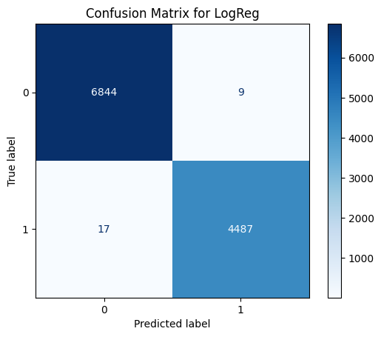
- Logistic Regression Confusion Matrix
Figure 4-LogReg confution matrix

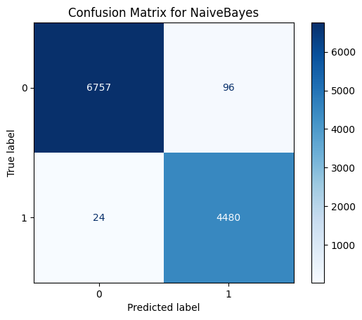
- Naïve Bayes Confusion Matrix
Figure 5-Naïve Bayes Confusion Matrix

- Random Forest Confusion Matrix
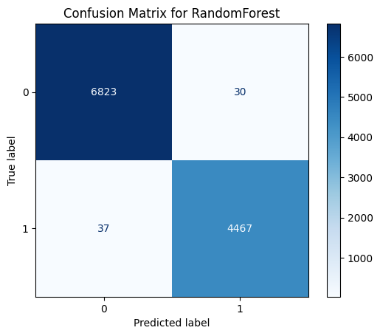
Figure 6 - Random Forest Confusion Matrix

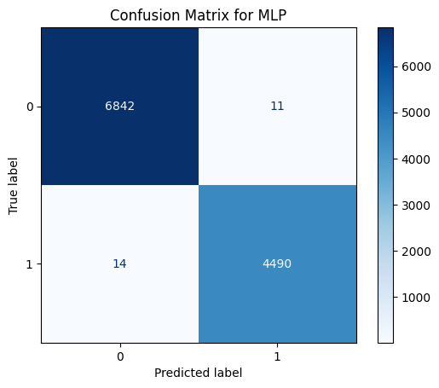
- MLP Confusion Matrix
Figure 7- MLP Confusion Matrix

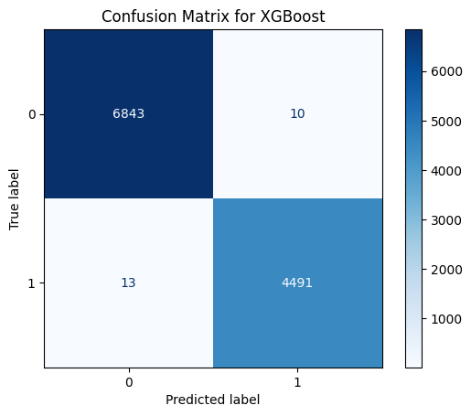
- XGBoost Confusion Matrix
Figure 8-XGBoost Confusion Matrix

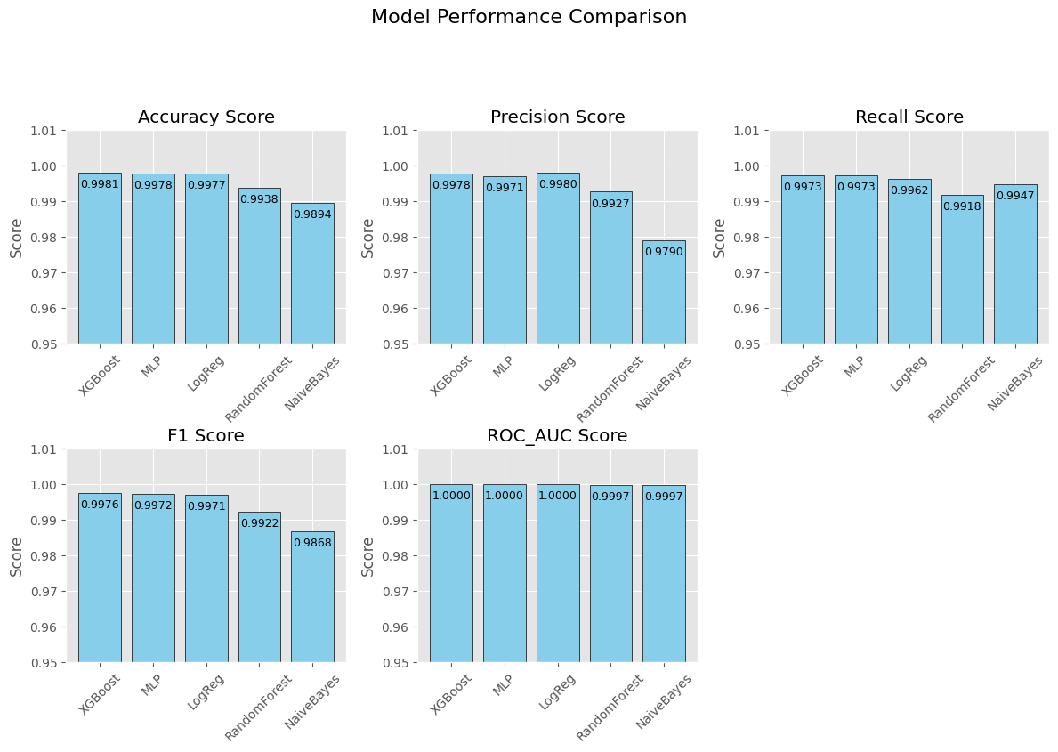
- Appendix C – Evaluation Screenshots
Figure 9- Model Performance Comparison
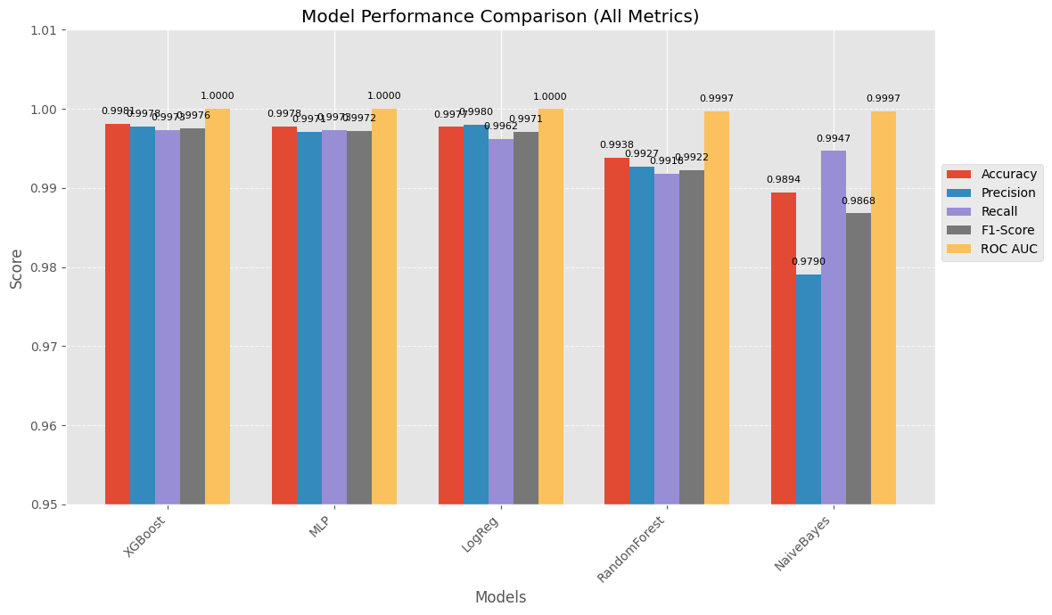
Figure 10- Model Performance Comparison (All matrix)
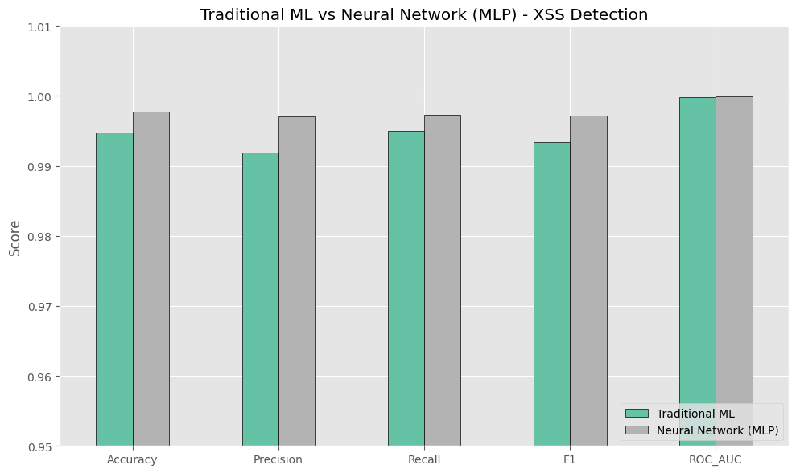
Figure 11- Traditional ML vs Neural Network
- Appendix D – Streamlit Application Screenshots

- Running and loading all models
Figure 12- STreamlit(Running and loading all models)

- Model selection and input payload

Figure 13- Streamlit (Input Payloads)
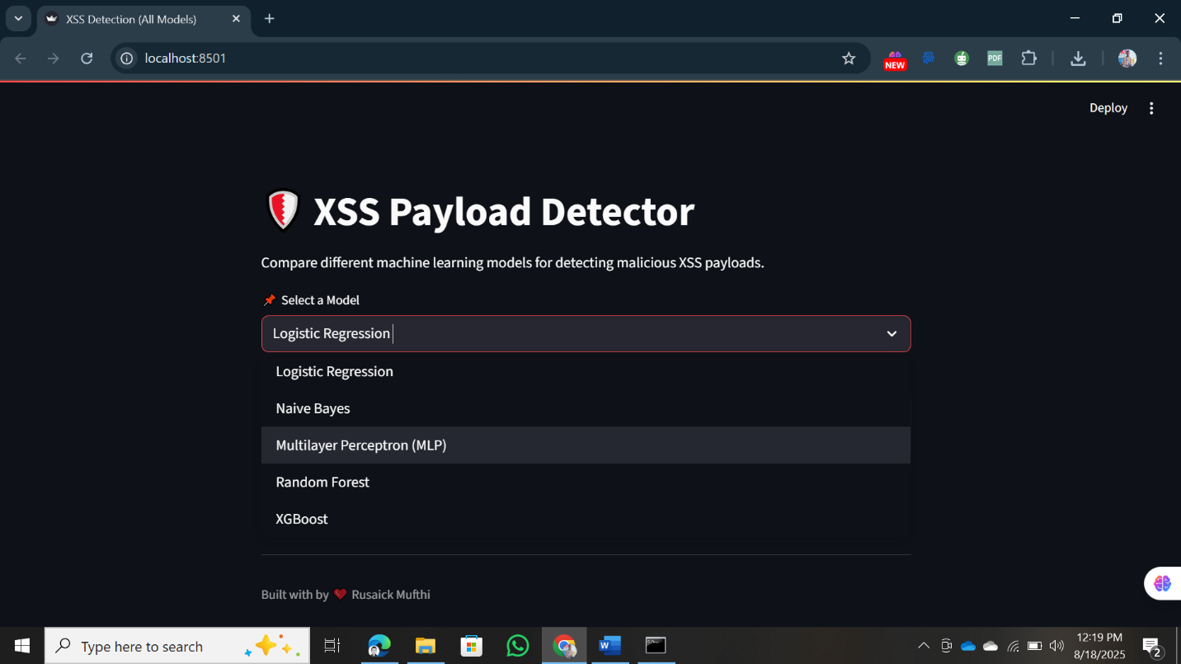
Figure 14- Streamlit (Model Selection)

- Appendix E – Code Snippets
- Example: TF-IDF Feature Extraction
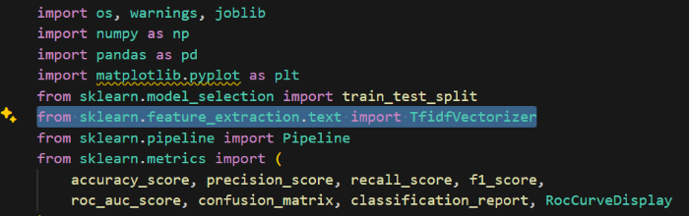
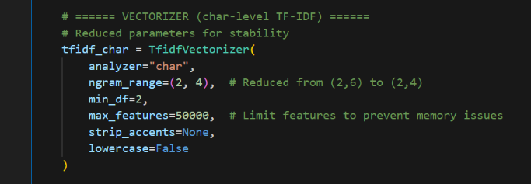
Figure 15- Code Snippets (TF-IDF Feature Extraction)
- Example: Model Training (XGBoost)
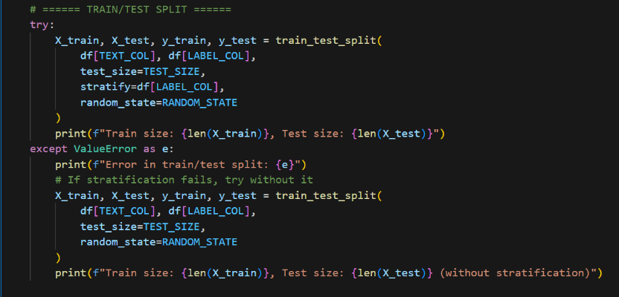
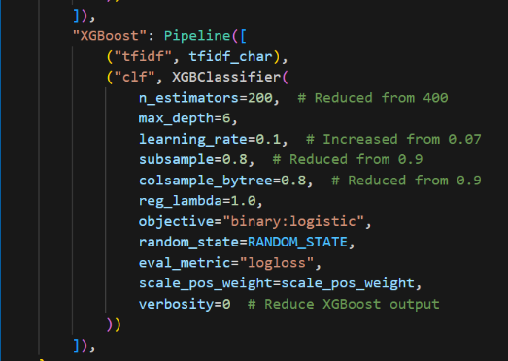
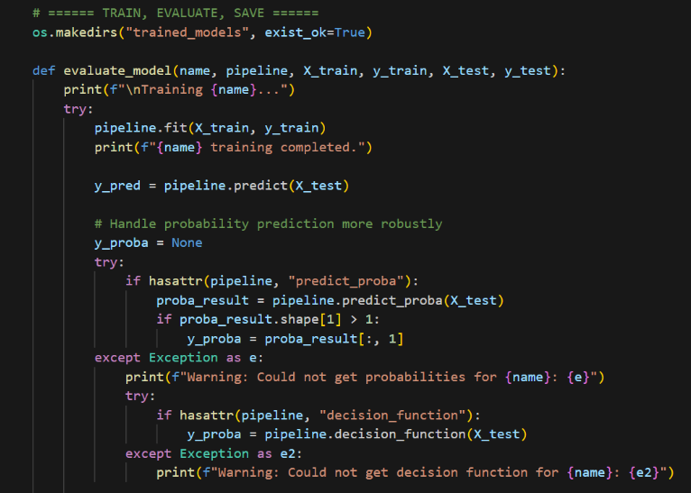
Figure 16- Code Snippets (Model Training (XGBoost))
- Example: Streamlit Inference
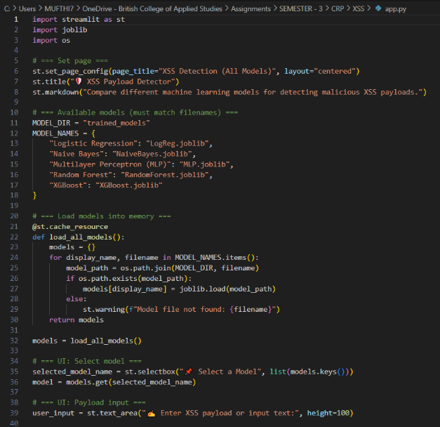
Figure 17- Code Snippets (Streamlit interface)
- Appendix F – Ethical Statement
- All datasets were obtained from open-source repositories (Kaggle, GitHub).
- No private or sensitive data was used.
- The developed system is for educational and research purposes only.

